ANALYSIS AND DESIGN
- ER-DIAGRAM
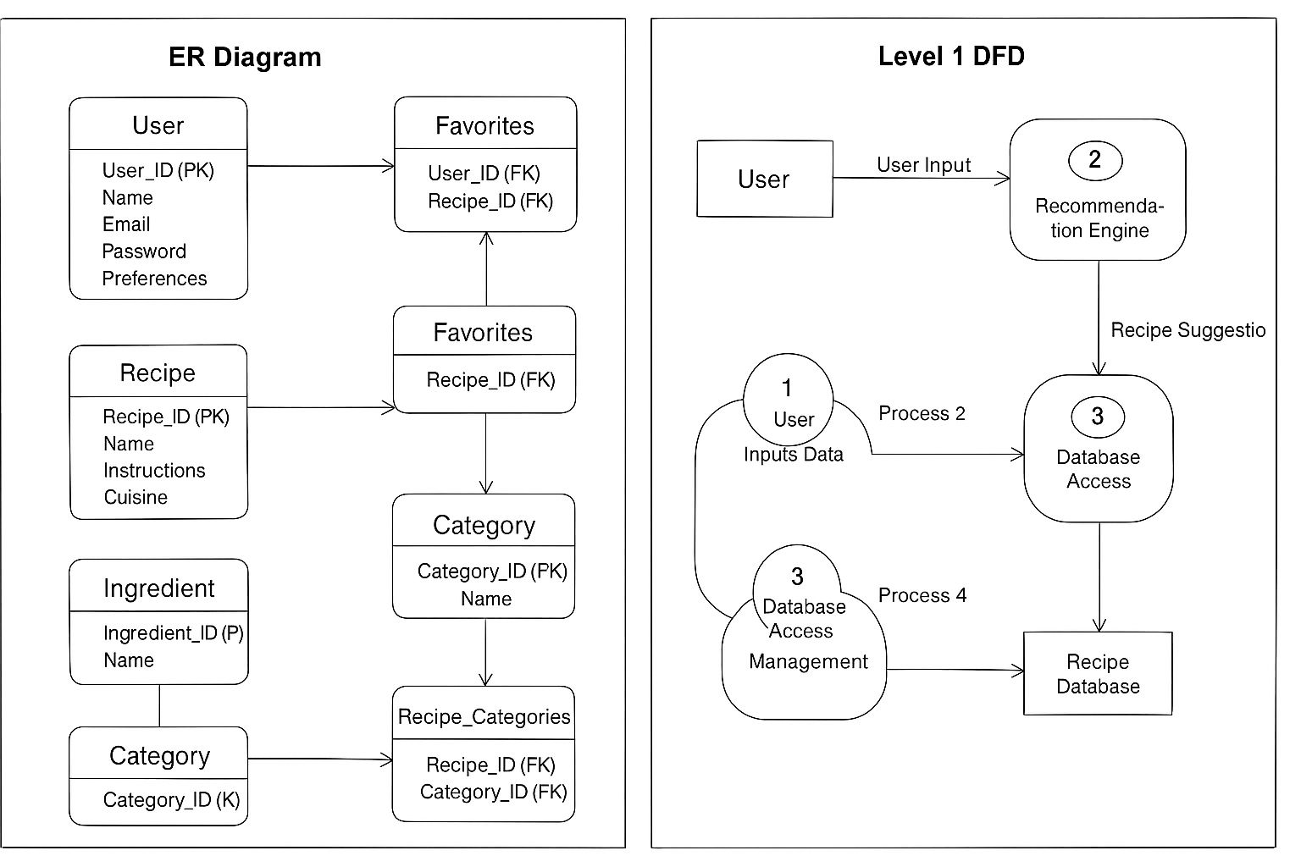
- DATA FLOW DIAGRAM
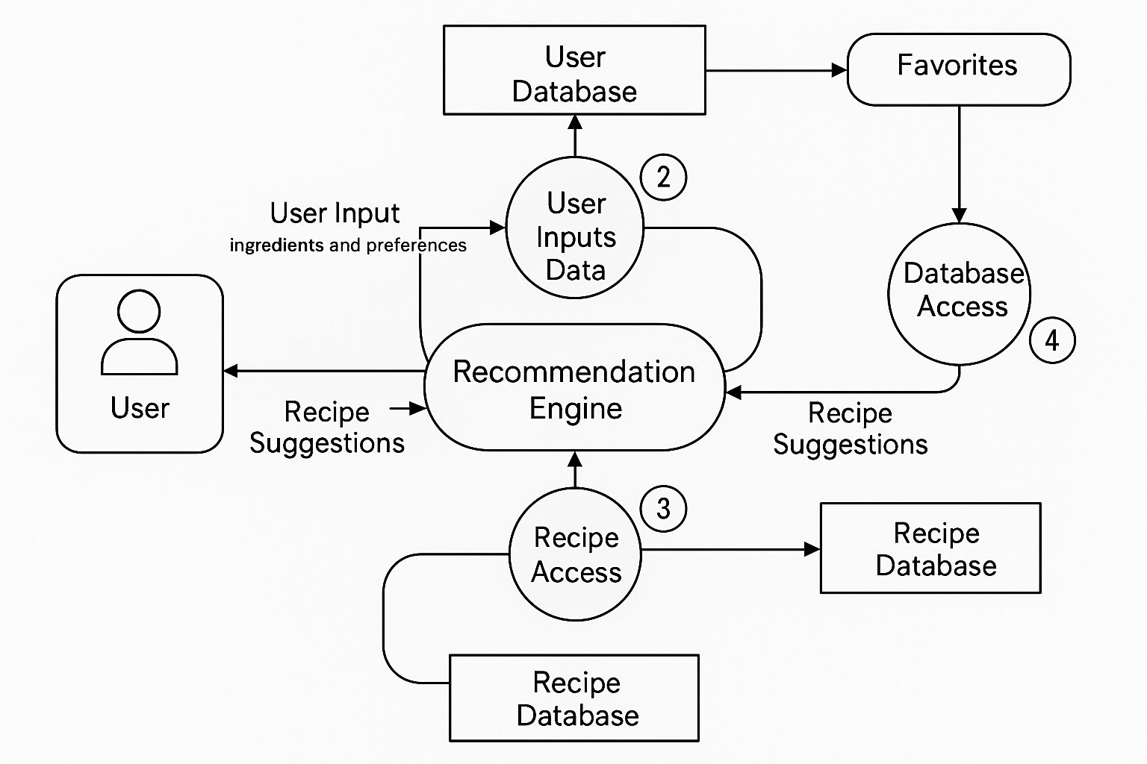

- TABLE

Users
Column Name | Data Type | Description
User_ID | INT (PK) | Unique ID for the user
Name | VARCHAR(100) | Name of the user
Email | VARCHAR(100) | User's email address
Password | VARCHAR(255) | Encrypted password
Preferences | TEXT | User's dietary preferences

Recipes
Column Name | Data Type | Description
Recipe_ID | INT (PK) | Unique ID for the recipe
Name | VARCHAR(255) | Recipe name
Instructions | TEXT | Recipe instructions
Cooking_Time | INT | Time required for cooking (in mins)
Cuisine | VARCHAR(100) | Cuisine type (e.g., Italian)
Category | VARCHAR(100) | Category (e.g., Vegan, Non-Vegan)

Ingredients
Column Name | Data Type | Description
Ingredient_ID | INT (PK) | Unique ID for the ingredient
Name | VARCHAR(100) | Name of the ingredient

Recipe_Ingredients
Column Name | Data Type | Description
Recipe_ID | INT (FK) | Foreign key to Recipes table
Ingredient_ID | INT (FK) | Foreign key to Ingredients table

Categories
Column Name | Data Type | Description
Category_ID | INT (PK) | Unique ID for the category
Name | VARCHAR(100) | Category name (e.g., Vegan)

Recipe_Categories
Column Name | Data Type | Description
Recipe_ID | INT (FK) | Foreign key to Recipes table
Category_ID | INT (FK) | Foreign key to Categories table

